HO TECHNICAL UNIVERSITY



FACULTY OFAPPLIED SCIENCES AND TECHNOLOGY
DEPARTMENT OF COMPUTER SCIENCE
DESIGN AND DEVELOPMENT OF A CLOUD-BASED SCHOOL MANAGEMENT SYSTEM FOR UHAS BASIC SCHOOL, HO.

NAMES INDEX NUMBERS
DUMEDAH KOBBY 0323080248
BOSSMAN STEPHEN ELIEZER 0323080231
MENSAH KOBBY DERRICK 0323080241
AKLAKU THEOPHILUS M.K JUNIOR 0323080201
DZIGBEDE PRECIOUS 0323080442

Contents
CHAPTER ONE 4
1.0 Introduction 4
1.2 Problem Statement 5
1.3 Aim and Objectives 6
Objectives 6
1.4 Significance of the Project 7
1.5 Scope of the Project 7
1.6 Organization of the Project 8
REFERENCES 9
CHAPTER TWO 10
2.1 Review of Related Works 10
2.2 Review of Related Systems 12
Features 12
Benefits 12
Drawbacks 13
Features 13
Benefits 13
Drawbacks 14
Features 14
Benefits 14
Drawbacks 15
2.2.1 Features 15
2.2.2 Benefits 17
2.2.3 Drawbacks 18
2.3.3 Problems of the Existing System 19
REFERENCES 20
CHAPTER THREE 21
THE PROPOSED SYSTEM 21
3.1 System Specification 21
3.1.1 Functional Requirements 21
3.1.2 Non-Functional Requirements 23
3.2 Selection of Technologies and Tools 24
3.3 Architecture of The System 25
3.4 Design of The System 28
3.4.1 Use Case Diagram 28
3.4.1(b) Sequence Diagram 30
3.4.2 Database Design 32
Entity Relationship Overview 36
REFERENCES 38

CHAPTER ONE

Introduction
The 21st century has witnessed an unprecedented expansion in Information and Communication Technology (ICT), fundamentally transforming how societies function and how organizations deliver services. Digital technologies such as cloud computing, artificial intelligence, big data analytics, mobile applications, and enterprise information systems have reshaped global industries including healthcare, finance, governance, manufacturing, and education. Organizations now depend heavily on information systems to enhance operational efficiency, ensure transparency, improve accountability, and support strategic decision-making (Laudon & Laudon, 2020). The global shift toward digital transformation has made technology integration not merely an option, but a necessity for institutional survival and competitiveness.
In both developed and developing countries, institutions are leveraging ICT to streamline administrative processes, reduce operational costs, improve data management, and increase stakeholder engagement. The diffusion of innovation theory suggests that technological advancement spreads progressively across societies, influencing institutional structures and operational frameworks (Rogers, 2003). As digital technologies continue to evolve, institutions that fail to adopt modern systems risk inefficiency, reduced productivity, and declining stakeholder confidence.
The education sector has not been exempted from this technological revolution. Educational institutions across the world are integrating ICT into teaching, learning, and administrative management. ICT integration enhances instructional delivery, facilitates access to learning resources, automates record keeping, and improves communication between schools and stakeholders (Tondeur et al., 2020). In addition, School Management Systems (SMS) enable institutions to centralize student data, monitor performance indicators, manage financial transactions, and generate administrative reports efficiently (Oyelere et al., 2020).
While traditional School Management Systems have improved administrative efficiency, many of these systems are locally hosted and constrained by infrastructure limitations, high maintenance costs, and restricted accessibility. As schools increasingly require scalable, flexible, and remotely accessible solutions, attention has shifted toward cloud-based technologies as a more sustainable alternative.
Cloud computing enhances educational technology by enabling remote access, scalability, real-time data synchronization, and improved data security. Cloud-based systems eliminate the need for expensive on-site servers and reduce long-term infrastructure costs while ensuring automatic backups and centralized data management (Almaiah et al., 2020). The adoption of a cloud-based architecture for this project is therefore justified by its flexibility, cost-effectiveness, accessibility, and sustainability. Through cloud platforms, authorized stakeholders including teachers, parents, administrators, and students can securely access relevant information from any location with internet connectivity
In Ghana, ICT adoption in education has steadily increased, supported by national digital transformation initiatives. Empirical studies indicate that ICT integration improves coordination, data accuracy, and administrative efficiency within educational institutions, although challenges such as infrastructure deficits and funding constraints remain significant (Boateng et al., 2021). Despite these advancements, many basic schools continue to rely on manual systems for academic documentation, fee collection, and administrative reporting.

1.2 Problem Statement
One major consequence of relying on manual academic management processes is the increased workload placed on teachers. Because teachers must prepare Schemes of Learning, record assessments, and compile reports by hand, a significant amount of their time is consumed by administrative duties rather than teaching. This reduces the quality and effectiveness of instructional delivery, as teachers have less time to prepare lessons, engage students, and provide individualized support. Over time, this may also lead to teacher fatigue and decreased productivity.
Another important consequence is the delay in providing feedback to students. Since assessments are recorded and processed manually, it takes longer for teachers to calculate scores, analyze performance, and communicate results. As a result, students do not receive timely feedback on their academic progress, which can negatively affect their ability to identify weaknesses and improve. Delayed feedback may also reduce student motivation and engagement in learning.
In addition, manual processes make it difficult for school management to effectively monitor and evaluate academic performance. Without a centralized and automated system, tracking trends, comparing student results, and generating reports becomes challenging and time-consuming. This limits the ability of management to make informed decisions, plan interventions, and implement strategies to improve overall academic performance.
Furthermore, the use of physical records exposes academic data to significant risks. Documents can easily be lost, damaged by environmental factors such as fire or water, or misplaced over time. There is also a higher likelihood of human errors in calculations and record-keeping, which can lead to inaccurate student results and reports. Such inaccuracies may affect students’ academic records and undermine the credibility of the school’s assessment system.
Finally, the inefficiency of manual record-keeping can hinder long-term academic planning and institutional development. The difficulty in retrieving historical data makes it challenging to analyze past performance and predict future trends. This limits the school’s ability to implement data-driven decisions and continuously improve its academic processes, ultimately affecting the overall quality of education provided.

1.3 Aim and Objectives
The main aim of this project is to design and develop a cloud-based School Management System for UHAS Basic School to enhance academic efficiency, improve financial transparency, strengthen stakeholder communication, and support informed decision-making.

Objectives
To achieve this aim, the project is guided by the following specific objectives
1. To develop a comprehensive electronic assessment management module that enables teachers to create, administer, mark, and store assignments, quizzes, and examinations digitally while maintaining secure and retrievable academic records.
2. To automate the preparation and storage of Schemes of Learning in order to reduce teachers’ administrative workload and ensure standardization and curriculum alignment.
3. To integrate a centralized digital curriculum repository that allows teachers to access approved instructional materials and align lesson content with national standards.
4. To design a real-time communication system that facilitates interaction between teachers, parents, and students through notifications, alerts, and secure messaging features.
5. To implement an academic monitoring and analytics feature capable of tracking attendance, evaluating performance trends, and forecasting examination outcomes.
6. To integrate secure mobile money and digital banking payment systems that allow convenient fee payment, automated receipt issuance, and transparent financial tracking.
7. To generate automated administrative and financial reports that support evidence-based decision-making by school management and board members.

1.4 Significance of the Project
The proposed system will significantly benefit teachers by reducing administrative burdens associated with lesson planning, grading, and report preparation. Automation of routine tasks will allow teachers to allocate more time to instructional delivery and individualized student support.
For parents, the system will provide real-time access to academic performance, attendance records, fee payment history, and school announcements. This increased transparency will strengthen parental involvement and enhance collaboration between home and school.
Students will benefit from improved academic monitoring and timely feedback. Predictive analytics and performance tracking will enable early identification of academic challenges, thereby promoting improved learning outcomes.
School management and board members will gain access to accurate financial and administrative reports, improving accountability, transparency, and strategic planning. Evidence-based decision-making will enhance institutional governance.

1.5 Scope of the Project
The scope of the project covers the design and development of a comprehensive School Management System. This system includes a Teaching and Learning Module, which will handle assessment processing, generate Schemes of Learning, provide access to the curriculum, and facilitate communication between teachers and students.
The Parents Module will enable parents to monitor their child’s academic progress, track attendance, make fee payments, and receive important notifications from the school.
The Finance Module will manage fee collection, generate receipts, send automated reminders for pending payments, and provide detailed accounting reports to support financial management.
The School Administration Module is responsible for managing staff, students, and other stakeholders, while also facilitating the generation of various administrative reports.
The System Administration Module will focus on user management, ensuring proper security measures, and providing technical support for smooth system operation.
The entire system will be cloud-based, allowing authorized users to access it remotely from anywhere, ensuring flexibility and convenience.

1.6 Organization of the Project
This project is organized into five chapters for clarity and structured presentation. Chapter One presents the introduction, background of the study, problem statement, aim and objectives, significance, scope, and organization of the project.
Chapter Two reviews related literature on school management systems and the role of information and communication technology in education.
Chapter Three describes the system analysis and design methodology, detailing how the system will be planned and structured for implementation.
Chapter Four covers system implementation and testing, explaining how the system is developed, deployed, and evaluated for performance and reliability.
Chapter Five presents the summary of the project, draws conclusions based on findings, and provides recommendations for future improvements and enhancements.

REFERENCES
Almaiah, M. A., Al-Khasawneh, A., & Althunibat, A. (2020). Exploring the critical challenges and factors influencing the e-learning system usage during the COVID-19 pandemic. Education and Information Technologies, 25(6), 5261–5280
Boateng, R., Mbrokoh, A. S., Boateng, S. L., Senyo, P. K., & Ansong, E. (2021). Determinants of e-learning adoption among students in Ghana. Information Development, 37(1), 97–112
Laudon, K. C., & Laudon, J. P. (2022). Management information systems: Managing the digital firm (17th ed.). Pearson Education Limited.
Oyelere, S. S., Suhonen, J., & Sutinen, E. (2020). M-learning: A review of Technologies and Pedagogical Models for Modern Education. Education and Information Technologies, 25(5), 3813–3837.

CHAPTER TWO

2.1 Review of Related Works
1. Web Based School Management System by Sharma and Gupta (2021)
Sharma and Gupta (2021) developed a web-based school management system aimed at improving the administrative and academic activities of educational institutions. The researchers explained that traditional paper-based methods used in schools often lead to delays, duplication of records, and calculation errors. Their proposed system was designed to automate major school activities such as student registration, attendance management, grading, fee management, and report generation.
The study further emphasized that the use of web technologies allows teachers, students, and administrators to access academic information from different locations through internet enabled devices. The system also improved communication between parents and schools by allowing parents to monitor students’ academic performance online. According to the researchers, automation reduces the workload of teachers and helps institutions maintain accurate and organized records.

2. Cloud Based School Management System by Almaiah et al. (2020)
Almaiah et al. (2020) examined the role of cloud-based technologies in school management systems and educational administration. The study explained that cloud computing has transformed the way educational institutions manage and store information by providing online platforms for data access, collaboration, and communication. The researchers noted that cloud-based school management systems enable institutions to securely store large volumes of academic records while reducing dependence on physical storage facilities.
The study also revealed that cloud systems provide flexibility because users can access information remotely from smartphones, tablets, and computers. Teachers can upload results and lesson materials online, while administrators can monitor school activities in real time. Despite the advantages, the researchers noted that institutions implementing cloud systems must address issues related to cyber security and internet reliability.
3. Automated Student Information Management System by Patel and Jain (2019)
Patel and Jain (2019) designed an automated student information management system to improve the handling of academic records within educational institutions. The researchers stated that many schools still rely heavily on manual systems for storing student data, calculating examination results, and preparing reports. Such manual processes are often time consuming and prone to human errors.
The proposed system was developed to automate activities such as attendance tracking, examination processing, grading, and student profile management. According to the study, the system improves data accuracy and ensures faster retrieval of information whenever needed. The researchers also explained that the automation of repetitive academic tasks reduces teachers’ workload and improves efficiency within the school environment.
4. Mobile School Management Application by Oyelere et al. (2020)
Oyelere et al. (2020) investigated the use of mobile technologies in school management systems and digital learning environments. The study highlighted the growing importance of mobile applications in improving communication, accessibility, and management of academic activities within schools. According to the researchers, mobile school management systems allow teachers, students, and parents to access school information conveniently through smartphones and tablets.
The researchers further explained that mobile applications improve real time monitoring of student performance and attendance. Parents can receive updates about their children’s academic progress instantly, while teachers can upload assessments and communicate with stakeholders more effectively. However, the study pointed out that mobile systems may face challenges such as device compatibility issues and data security risks.

5. Integrated School Management System by Boateng et al. (2021)
Boateng et al. (2021) studied the implementation of integrated school management systems in Ghanaian educational institutions. The researchers explained that integrated systems combine academic, administrative, and communication functions into a single digital platform. The study highlighted that many schools in Ghana are gradually adopting ICT based management systems to improve efficiency and service delivery.
According to the study, integrated school management systems help administrators coordinate activities such as student admissions, fee payment management, report generation, and staff administration more effectively. The researchers also emphasized that centralized databases improve accessibility and reduce duplication of records. However, they noted that challenges such as inadequate ICT infrastructure, limited funding, and resistance to change continue to affect implementation in some institutions

2.2 Review of Related Systems
Several school management systems have been developed to address administrative and academic challenges in educational institutions. Below are some of the systems
1. Fedena School Management System
Fedena is a web-based school management software designed to automate administrative and academic activities within educational institutions. The system provides tools for managing student records, attendance, examinations, and communication between stakeholders.

Features
- Student information management – Stores and organizes student records such as personal details, academic performance, and enrollment information in one system.
- Attendance tracking – Records and monitors student attendance automatically, making it easier to identify absences and lateness.
- Online examination management – Enables teachers to create, administer, and grade exams digitally.
- Automated report generation – Produces academic and administrative reports automatically, saving time and reducing errors.
- Communication portal – Provides a platform for communication between students, teachers, parents, and administrators.

Benefits
- Improves administrative efficiency – Streamlines school operations by automating routine tasks and processes.
- Reduces paperwork – Minimizes the use of physical documents by storing and managing information electronically.
- Enhances communication – Facilitates quick and effective information sharing among all school stakeholders.
- Provides centralized data management – Keeps all school-related data in a single, easily accessible system.

Drawbacks
- Some features require premium subscription – Advanced tools and functionalities may only be available through paid plans.
- May require technical training – Users may need training to fully understand and utilize the system's features.
2. OpenSIS
OpenSIS is an open-source student information system used for managing school operations. It helps schools manage attendance, grades, scheduling, and student records.

Features
- Student enrollment management – Simplifies the process of registering students and maintaining their admission records.
- Attendance monitoring – Tracks and records student attendance to help manage participation and identify absenteeism.
- Gradebook management – Allows teachers to record, calculate, and manage students' grades in a centralized system.
- Scheduling system – Organizes class timetables, exams, and other school activities efficiently.
- Parent and student portal – Provides parents and students with access to academic records, attendance reports, and school updates.

Benefits
- Open-source and customizable – The software can be modified to meet the specific needs of an institution without licensing restrictions.
- Supports efficient data management – Helps store, organize, and retrieve educational data quickly and accurately.
- Improves accessibility to records – Enables authorized users to access student and school information anytime and from various locations.
- Cost-effective for institutions – Reduces software expenses since the system is typically free to use and customize.

Drawbacks
- Requires technical expertise for setup – Installation, customization, and maintenance often require IT knowledge and skills.
- Limited support compared to paid systems – Users may rely mainly on community forums and documentation rather than dedicated customer support.
- Security risks if poorly maintained – Failure to update and secure the system regularly can expose it to cyber threats and data breaches.

3. Moodle
Moodle is an online learning management system widely used in schools and universities to support digital learning and academic management.

Features
- Online learning environment – Provides a digital platform where students can access course materials and participate in learning activities.
- Assignment submission – Allows students to submit assignments electronically and receive feedback from instructors.
- Quiz and assessment tools – Enables teachers to create and manage quizzes, tests, and other forms of student assessment.
- Communication forums – Facilitates discussions and collaboration among students and teachers through online forums.
- User management – Controls user accounts, roles, and permissions to ensure secure access to the system.

Benefits
- Supports remote learning – Enables students and teachers to teach and learn from any location with internet access.
- Encourages interactive learning – Promotes engagement through discussions, quizzes, and collaborative activities.
- Flexible and scalable – Can accommodate different class sizes and educational needs while adapting to institutional growth.
- Accessible online – Provides easy access to learning resources and activities through the internet.

Drawbacks
- .
- May be difficult for beginners – New users may require time and training to become familiar with the platform's features.
- Requires regular system maintenance – Ongoing updates, backups, and technical support are necessary to keep the system running smoothly and securely.

2.2.1 Features

The reviewed school management systems possess several important features that support academic and administrative activities within educational institutions. These features are designed to improve efficiency, simplify record management, enhance communication, and automate repetitive tasks. The major features identified from the reviewed systems are discussed below.
- Domain Integration with University Systems
This feature ensures that the school management system is linked to an official institutional domain. By doing so, access to the system is controlled and restricted to authorized users such as teachers, administrators, students, and parents. It enhances data security, promotes standardization, and ensures that all academic activities are carried out within a unified digital environment. Additionally, domain integration supports centralized data storage, making it easier to manage large volumes of academic records efficiently.
- Remote Record Preparation
The system allows teachers to prepare lesson notes, input student scores, and manage academic records from any location with internet access. This flexibility eliminates the limitations of physical presence within the school environment. Teachers can work from home or any remote location, which improves productivity and ensures continuity of academic activities even during disruptions such as holidays or emergencies.
- Assessment and Grading System
This feature enables teachers to input various forms of student assessments, including assignments, projects, quizzes, midterm exams, and final examinations. The system automatically calculates total scores and grades based on predefined criteria. This reduces human error, ensures consistency in grading, and simplifies the evaluation process.
- Midterm and End-of-Term Report Generation
The system automates the generation of academic reports by compiling student performance data into structured formats. Teachers no longer need to manually calculate and write reports, as the system generates them instantly. This improves efficiency and ensures that reports are accurate, consistent, and delivered on time.
- Cumulative Record Calculation
The system tracks and calculates students’ academic performance over multiple terms and semesters. This allows for the generation of cumulative results, which provide a comprehensive view of a student’s academic progress. Such data is essential for long-term evaluation and decision-making.
- Lesson Notes and Learner Plan Management
Teachers can create, store, and update lesson notes and learner plans digitally. This ensures proper organization of teaching materials and supports curriculum alignment. It also allows teachers to reuse and modify existing materials, improving teaching efficiency.
- Teacher Record Management
Teachers are required to continuously update student records, including academic performance and attendance. This ensures that all data is current and accurate, enabling real-time monitoring of student progress.
- Commenting System
The system allows teachers to include personalized comments or remarks on student reports. These comments provide qualitative insights into student behavior, strengths, and areas for improvement, complementing quantitative scores.
- System Compatibility
The system is designed to work across multiple devices such as smartphones, tablets, and computers. This ensures accessibility and convenience for all users regardless of the device they use.
- Printing Functionality
Both teachers and parents can print reports and academic records directly from the system. This ensures that physical copies are available when needed for official or personal use.

2.2.2 Benefits

- Flexibility for Teachers
Teachers can perform their duties from any location, which reduces stress and increases efficiency. This flexibility is particularly beneficial in situations where physical access to the school is limited.
- Improved Academic Tracking
Continuous updating of records allows teachers and administrators to monitor student performance in real time. This helps in identifying struggling students early and providing timely intervention.
- Automated Report Generation
The system significantly reduces the time and effort required to prepare reports. Reports are generated instantly, ensuring timely communication of academic performance.
- Time Efficiency
Automation of repetitive tasks such as grading and calculations saves time, allowing teachers to focus more on teaching and student engagement.
- Better Communication
Parents can access student reports and print them, which improves transparency and strengthens the relationship between parents and the school.

- Data Accuracy
Automated calculations reduce the likelihood of errors, ensuring that student records are reliable and trustworthy.
- Enhanced Teaching Planning
Digital lesson notes and learner plans help teachers organize their teaching effectively and maintain consistency in content delivery.
- Centralized Data Management
All data is stored in one system, making it easier to manage, retrieve, and analyze information.

2.2.3 Drawbacks

- Dependence on Internet Connectivity
Since the system is cloud-based, it requires a stable internet connection. Poor connectivity can limit access and disrupt system usage.
- High Initial Cost
The development, deployment, and maintenance of the system may require significant financial investment.
- Need for Training
Teachers and staff may require training to effectively use the system, especially if they are not familiar with digital tools.
- Technical Issues
System errors, bugs, or downtime can temporarily disrupt operations and affect productivity.
- Data Security Risks
Sensitive student and financial data must be protected. Without proper security measures, the system may be vulnerable to cyber threats.

2.3.3 Problems of the Existing System

- Difficulty in Record Preparation
Teachers must be physically present in school to prepare lesson notes and update records, which limits flexibility and productivity.
- Time-Consuming Calculations
Manual calculation of grades and cumulative results takes a significant amount of time and effort.
- High Risk of Errors
Human errors in calculations and record-keeping can lead to inaccurate results, which may affect students’ academic outcomes.
- Poor Record Management
Paper-based records are difficult to organize and maintain. They can easily be misplaced or damaged.
- Limited Accessibility
Records are stored physically and cannot be accessed remotely, making it difficult for stakeholders to retrieve information when needed.
- Inefficient Report Generation
Preparing reports manually is slow and often delays the release of academic results.
- Lack of Real-Time Updates
Parents and administrators do not have immediate access to student performance data, limiting timely intervention.
- Poor Communication
Communication between teachers and parents is often delayed or ineffective due to reliance on physical meetings or written notices

REFERENCES
Sharma, R., & Gupta, P. (2021). Web Based School Management System for Educational Institutions. International Journal of Computer Applications, 174(12), 25 to 31.
Almaiah, M. A., Al-Khasawneh, A., & Althunibat, A. (2020). Exploring the Critical Challenges and Factors Influencing the E-Learning System Usage During COVID-19 Pandemic. Education and Information Technologies, 25(6), 5261 to 5280.
Patel, S., & Jain, R. (2019). Automated Student Information Management System. International Journal of Advanced Research in Computer Science, 10(4), 45 to 52.
Oyelere, S. S., Suhonen, J., & Sutinen, E. (2020). Mobile Learning Technologies in Education: Opportunities and Challenges. Education and Information Technologies, 25(5), 3853 to 3875
Boateng, R., Mbrokoh, A. S., Boateng, S. L., Senyo, P. K., & Ansong, E. (2021). Determinants of E-Learning Adoption Among Students in Ghanaian Educational Institutions. Information Development, 37(4), 596 to 609.
Moodle Pty Ltd. (2022). Moodle Learning Management System.
Foradian Technologies. (2022). Fedena School Management Software.
OpenSIS Inc. (2021). OpenSIS Student Information System.
Rogers, E. M. (2003). Diffusion of innovations (5th ed.). Free Press.
Tondeur, J., Scherer, R., Siddiq, F., & Baran, E. (2020). Enhancing Pre-service Teachers’ Technological Pedagogical Content Knowledge (TPACK): A mixed-method study. Computers & Education, 145, 103727.

CHAPTER THREE

THE PROPOSED SYSTEM

3.1 System Specification
System specification defines the functional and non-functional requirements of a software system prior to design and development (Sommerville, 2016). For the Cloud-Based School Management System at UHAS Basic School, the specification was derived from the identified problems in the existing manual system, the objectives in Chapter One, and the gaps from related systems reviewed in Chapter Two. The specification addresses the need to improve academic administration, enhance communication, automate financial processes, and support evidence-based decision-making.
The system specification is presented in two parts: functional requirements, which define the specific capabilities the system must provide, and non-functional requirements, which establish the quality standards and operational constraints the system must satisfy.
The following sections present the functional requirements organized by system module.

3.1.1 Functional Requirements
Functional requirements describe the specific behaviors and services the system must deliver (Sommerville, 2016). They were determined based on the operational needs of UHAS Basic School and are organized by module below.
(a) User Authentication and Access Control
- Role-based access control for Administrator, Teacher, Parent, and Student roles.
- Secure credential verification and JWT-based session management.
- Password policy enforcement, recovery via email/phone, and auto logout of inactive sessions.
- Audit trail recording all login events with timestamps and IP addresses.
(b) Student Enrolment and Profile Management
- Enrolment of students with unique ID, personal details, and class assignment.
- Comprehensive profiles including academic history, attendance, fee status, and parent contacts.
- Search, filter, and sort student records; support for deactivation and withdrawal.
(c) Assessment and Grading Management
- Input of class scores, midterm scores, and end-of-term examination scores per subject per term.
- Automated total score calculation using the prescribed 40% class score / 60% exam weighting.
- Automatic grade and remark assignment; duplicate entry prevention; change log for edits.
- Cumulative academic record tracking across terms and academic years.
(d) Scheme of Learning and Curriculum Management
- Digital creation, upload, retrieval, and reuse of Schemes of Learning from any location.
- Structured templates aligned with the Ghana Education Service curriculum framework.
- Centralized curriculum repository with administrator review and approval workflow.
(e) Attendance Management
- Daily attendance recording (Present, Absent, Late) per student per class.
- Automated absence threshold notifications to parents; attendance summaries in reports.
(f) Academic Report Generation
- Automated midterm and end-of-term reports with scores, grades, attendance, and remarks.
- Class position calculation; class-level performance statistics per subject.
- Reports downloadable in printable format and sent electronically to parents.
(g) Communication and Notification Module
- In-system messaging between administrators, teachers, parents, and students.
- Automated push and SMS notifications for results, fee deadlines, and attendance alerts.
- Broadcast messaging to all users or specific groups; message inbox with read status.
(h) Fee and Financial Management
- Mobile money integration (MTN, Vodafone Cash, AirtelTigo) and digital banking for fee payment.
- Automated receipt generation; detailed fee payment history per student.
- Outstanding balance tracking with automated reminders; configurable fee structures.
- Financial reports summarizing income, outstanding balances, and payment trends.
(i) Reporting and Analytics
- Administrator dashboard with KPIs: performance trends, attendance rates, financial summaries.
- Comparative reports across terms; predictive analytics to flag at-risk students.
- Export in PDF; graphical visualizations (bar charts, line graphs, pie charts).

3.1.2 Non-Functional Requirements
Non-functional requirements define the quality attributes and constraints the system must satisfy beyond its functional capabilities (Sommerville, 2016). Key requirements are summarized below.
(a) Performance
- Page load and response time within 3 seconds under standard network conditions.
- Support for a minimum of 200 concurrent users without performance degradation.
- Data caching to reduce repeated database calls for frequently accessed data.
(b) Security
- HTTPS with SSL/TLS for all data transmission; bcrypt hashing for stored passwords.
- Role-based access control at application and database levels; comprehensive audit logs.
- Input validation and sanitization to prevent SQL injection and XSS attacks.
(c) Reliability and Availability
- Minimum 99% annual uptime; automated daily database backups to distributed cloud storage.
- Graceful error handling and failover mechanism to backup server instances.
(d) Scalability
- Modular, microservices-compatible architecture for independent component scaling.
- AWS horizontal auto-scaling when concurrent load exceeds predefined thresholds.
(e) Usability
- Intuitive, responsive interface across desktop, tablet, and smartphone screen sizes.
- Contextual help, tooltips, and user guides; clear non-technical error messages.
(f) Maintainability
- Component-based architecture; thoroughly documented source code and developer guide.
- Version control via Git; new modules addable without restructuring existing codebase.

3.2 Selection of Technologies and Tools
The technology stack was selected based on cost-effectiveness, maturity, cloud deployment compatibility, security capabilities, and alignment with system requirements (Pressman & Maxim, 2020).

Category | Technology / Tool | Justification
Frontend | React.js | Component-based UI with fast rendering via virtual DOM (Meta, 2023).
Backend | Node.js + Express.js | Event-driven, non-blocking I/O model suited to multiple concurrent requests; RESTful API construction.
Database | Supabase (PostgreSQL) | Supabase provides a fully managed PostgreSQL database with built-in authentication, real-time subscriptions, and a RESTful API layer. Its open-source foundation and generous free tier make it well-suited for academic and early-stage development
Cloud Hosting | Vercel | Vercel offers seamless deployment for React.js frontends with zero-configuration CI/CD, automatic HTTPS, and a global edge network for fast content delivery. Its free tier supports the current development and testing phase, with straightforward scaling options available as the system grows.
Authentication | JSON Web Tokens (JWT) | Stateless authentication for securing API endpoints across multiple user roles.
Payment | Payment Gateway (Planned) | Payment gateway integration has not yet been implemented at this stage of development. Future work will incorporate a suitable Ghanaian payment solution (such as Paystack or mobile money APIs for MTN, Vodafone Cash, and AirtelTigo) to enable online school fee payment once the core system modules are stable
Version Control | Git / GitHub | Change tracking, collaborative development, and code rollback support.
IDE | Visual Studio Code | Lightweight editor with Git integration, debugging, and JavaScript/React plugin support.
API Testing | Postman | Validation of all RESTful API endpoints before frontend integration.
Table 3.1: Summary of Selected Technologies and Tools

3.3 Architecture of The System
The system adopts a three-tier client-server architecture deployed on Amazon Web Services (AWS), providing cloud-based accessibility, high availability, and scalability (Pressman & Maxim, 2020; Laudon & Laudon, 2022).
Tier 1: Presentation Layer (Client Side)
Built with React.js, this layer renders four role-based dashboards (Administrator, Teacher, Parent, Student) and communicates with the server exclusively through RESTful API calls over HTTPS. A fully responsive design ensures compatibility across all device types.
Tier 2: Application Logic Layer (Server Side)
Developed with Node.js and Express.js, this layer handles authentication via JWT, grade calculations, report generation, fee payment processing through Paystack and Mobile Money APIs, notification dispatch, and analytics. Business logic is isolated from both the UI and the database.
Tier 3: Data Layer (Database)
A MySQL relational database normalized to Third Normal Form (3NF) stores all user accounts, student records, assessments, transactions, and communication logs. Hosted on Amazon RDS with automated backups and multi-availability-zone replication. All database access is mediated exclusively through the Application Logic Layer.
Cloud Infrastructure (AWS)
EC2 instances host the Node.js backend; Amazon RDS hosts the MySQL database; Amazon S3 stores uploaded curriculum materials and generated reports; CloudFront handles content delivery. Auto-scaling ensures performance under variable load.
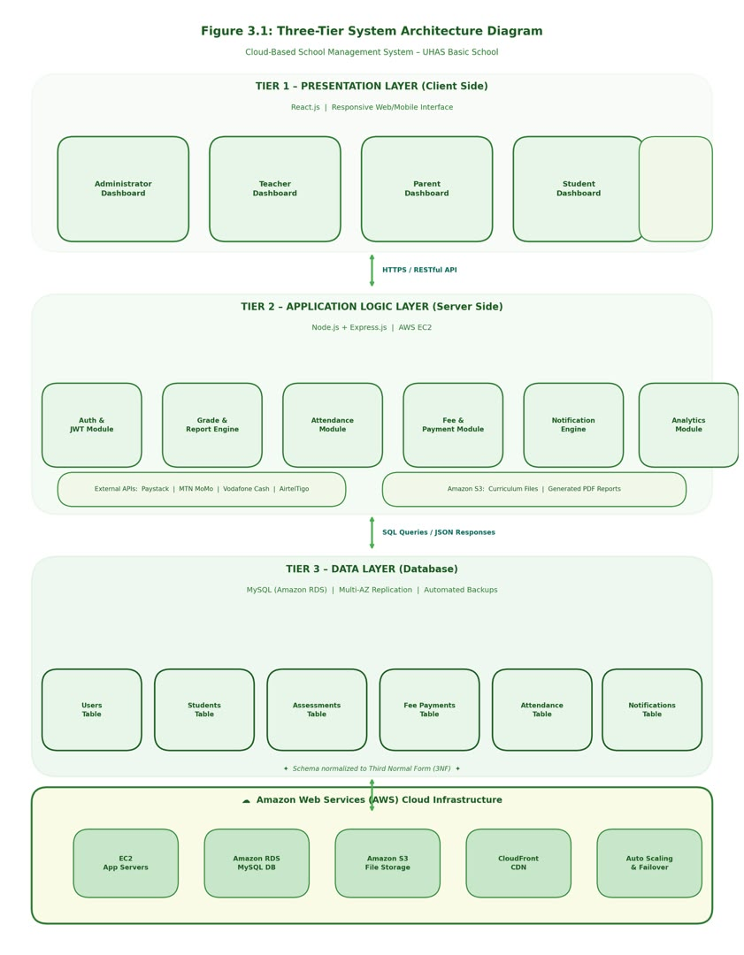

Figure 3.1: Three-Tier Architecture of the Cloud-Based School Management System

3.4 Design of The System
System design translates the requirements and architecture into a blueprint guiding construction (Sommerville, 2016). It encompasses process modeling through a Use Case Diagram and Sequence Diagram, and data modeling through the database design.

3.4.1 Use Case Diagram
The Use Case Diagram represents the system's functional scope from the perspective of five actors: System Administrator, Teacher, Parent, Student, and System (automated background processes). Table 3.2 summarizes the principal use cases.

UC ID | Actor | Use Case Description
UC-01 | Administrator | Create, modify, and deactivate user accounts for all roles
UC-02 | Administrator | Enrol new students, assign classes, and manage student profiles
UC-03 | Administrator | Configure fee structures and generate financial reports
UC-04 | Administrator | Send broadcast notifications and manage announcements
UC-05 | Teacher | Input, update, and manage student assessment scores
UC-06 | Teacher | Create, upload, and retrieve Schemes of Learning
UC-07 | Teacher | Record and manage daily student attendance
UC-08 | Teacher | Generate midterm and end-of-term academic reports
UC-09 | Teacher | Communicate with parents and students
UC-10 | Parent | View, download, and print child's academic reports
UC-11 | Parent | Pay school fees via mobile money or digital banking
UC-12 | Parent | Receive school notifications, alerts, and payment reminders
UC-13 | Student | View academic results and download learning materials
UC-14 | Student | View attendance records and receive notifications
UC-15 | System | Auto-generate reports, dispatch reminders, perform daily backups
Table 3.2: Summary of Use Cases for the Cloud-Based School Management System

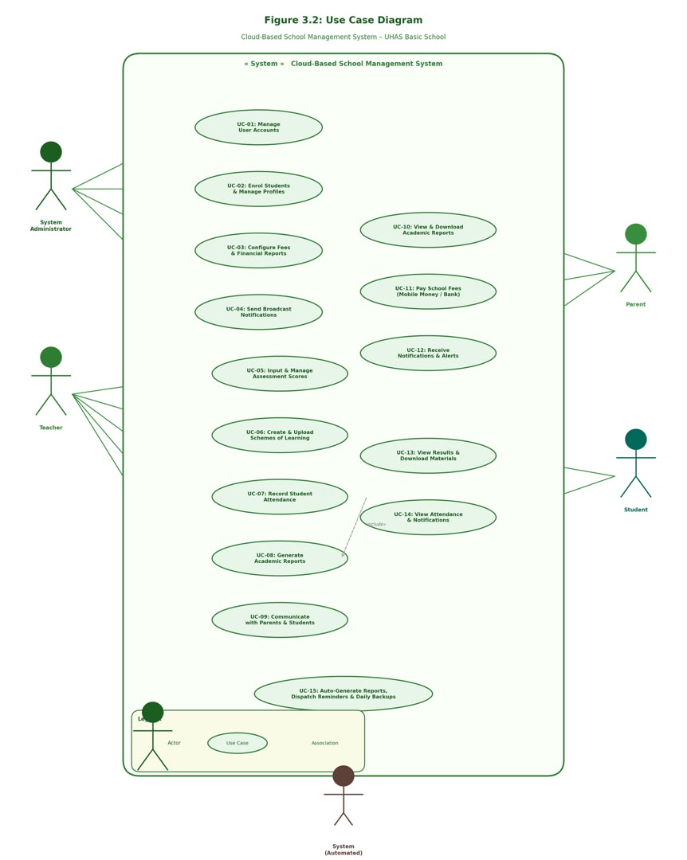
Figure 3.2: Use Case Diagram of the Cloud-Based School Management System

3.4.1(b) Sequence Diagram
The Sequence Diagram below models the Teacher Score Entry and Academic Report Generation workflow (UC-05 and UC-08). The Teacher authenticates via JWT, selects a class and subject, inputs scores, and the Application Logic Layer calculates totals using the 40%/60% weighting formula. Grades are persisted to the Assessments table, reports are compiled and saved to Amazon S3, and download links are made available to both Teachers and Parents.
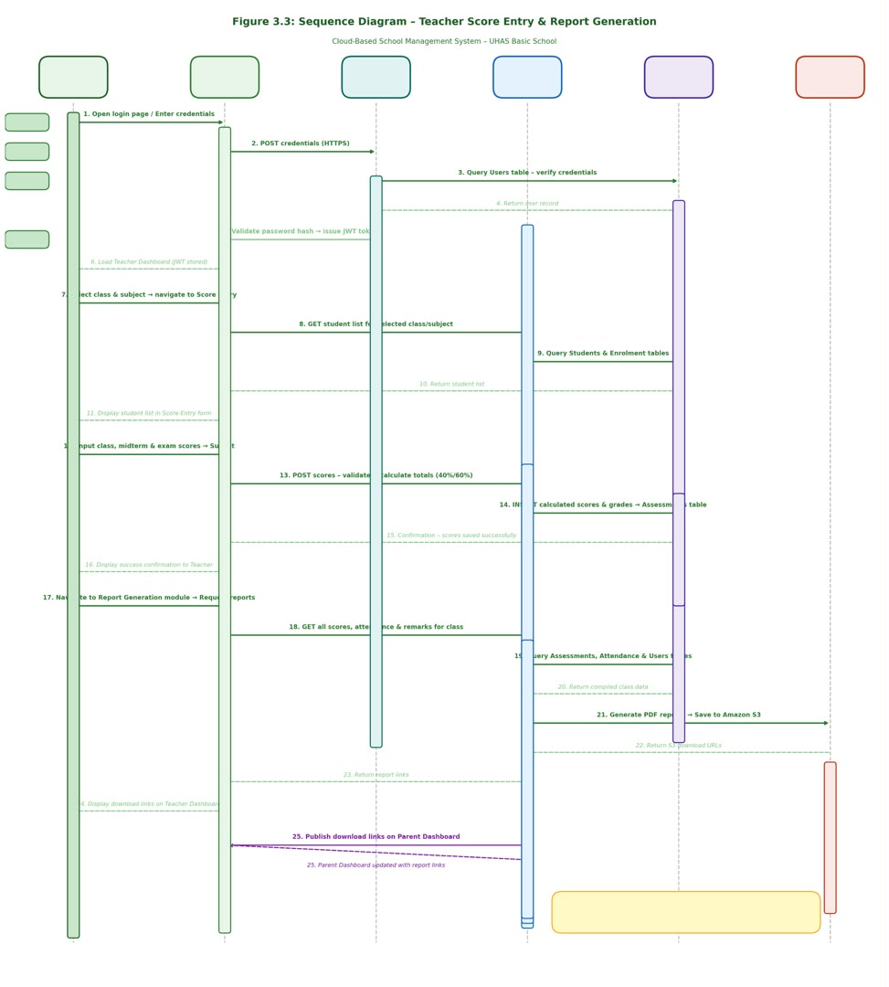
Figure 3.3: Sequence Diagram for Teacher Score Entry and Report Generation

3.4.2 Database Design
The database is designed using MySQL, normalized to Third Normal Form (3NF) to eliminate redundancy and prevent anomalies (Pressman & Maxim, 2020). The principal tables are described below.
(i) Users Table
Field Name | Data Type | Key | Description
user_id | INT (AUTO_INCREMENT) | PRIMARY KEY | Unique identifier for each user
username | VARCHAR(100) | UNIQUE, NOT NULL | User login name
password_hash | VARCHAR(255) | NOT NULL | bcrypt-hashed password
role | ENUM | NOT NULL | Admin, Teacher, Parent, Student
full_name | VARCHAR(150) | NOT NULL | Full name of the user
email | VARCHAR(150) | UNIQUE | Email for notifications and recovery
status | ENUM | DEFAULT Active | Active or Inactive
Table 3.3: Users Table
(ii) Students Table
Field Name | Data Type | Key | Description
student_id | INT (AUTO_INCREMENT) | PRIMARY KEY | Unique student record identifier
user_id | INT | FOREIGN KEY → Users | References the student's user account
student_number | VARCHAR(50) | UNIQUE, NOT NULL | Unique enrolment number
class_id | INT | FOREIGN KEY → Classes | Class the student is assigned to
parent_id | INT | FOREIGN KEY → Users | References the parent/guardian account
status | ENUM | DEFAULT Active | Active or Withdrawn
Table 3.4: Students Table
(iii) Assessments Table
Field Name | Data Type | Key | Description
assessment_id | INT (AUTO_INCREMENT) | PRIMARY KEY | Unique assessment record identifier
student_id | INT | FOREIGN KEY → Students | References the assessed student
subject_id | INT | FOREIGN KEY → Subjects | References the subject assessed
term_id | INT | FOREIGN KEY → Terms | References the academic term
class_score | DECIMAL(5,2) | NOT NULL | Coursework score out of 40
exam_score | DECIMAL(5,2) | NOT NULL | End-of-term exam score out of 60
total_score | DECIMAL(5,2) | COMPUTED | Automatically calculated total
grade | VARCHAR(5) | COMPUTED | Letter grade: A, B, C, D, or F
Table 3.5: Assessments Table

(iv) Fee Payments Table
Field Name | Data Type | Key | Description
payment_id | INT (AUTO_INCREMENT) | PRIMARY KEY | Unique payment transaction identifier
student_id | INT | FOREIGN KEY → Students | Student the payment is for
term_id | INT | FOREIGN KEY → Terms | Academic term of payment
amount_paid | DECIMAL(10,2) | NOT NULL | Amount paid in Ghana Cedis (GHS)
payment_method | ENUM | NOT NULL | Mobile Money, Bank Transfer, or Cash
payment_status | ENUM | DEFAULT Pending | Paid, Pending, or Failed
receipt_number | VARCHAR(50) | UNIQUE | Auto-generated receipt number
Table 3.6: Fee Payments Table
(v) Attendance Table
Field Name | Data Type | Key | Description
attendance_id | INT (AUTO_INCREMENT) | PRIMARY KEY | Unique attendance record identifier
student_id | INT | FOREIGN KEY → Students | References the student
attendance_date | DATE | NOT NULL | Date of the attendance record
status | ENUM | NOT NULL | Present, Absent, or Late
recorded_by | INT | FOREIGN KEY → Users | Teacher who recorded attendance
Table 3.7: Attendance Table
(vi) Notifications Table
Field Name | Data Type | Key | Description
notification_id | INT (AUTO_INCREMENT) | PRIMARY KEY | Unique notification identifier
sender_id | INT | FOREIGN KEY → Users | User who sent the notification
recipient_id | INT | FOREIGN KEY → Users | Intended recipient
message | TEXT | NOT NULL | Full notification content
notification_type | ENUM | NOT NULL | Alert, Reminder, Announcement, or Message
is_read | TINYINT(1) | DEFAULT 0 | Read status: 0 = Unread, 1 = Read
Table 3.8: Notifications Table

Entity Relationship Overview
Each User may be associated with one Student, Teacher, or Parent record. A Student belongs to one Class and is linked to one Parent. Each Assessment record links one Student, one Subject, one Term, and one Teacher. A Fee Payment links one Student and one Term. Each Attendance record covers one Student on a specific date. The ER Diagram below illustrates these relationships.
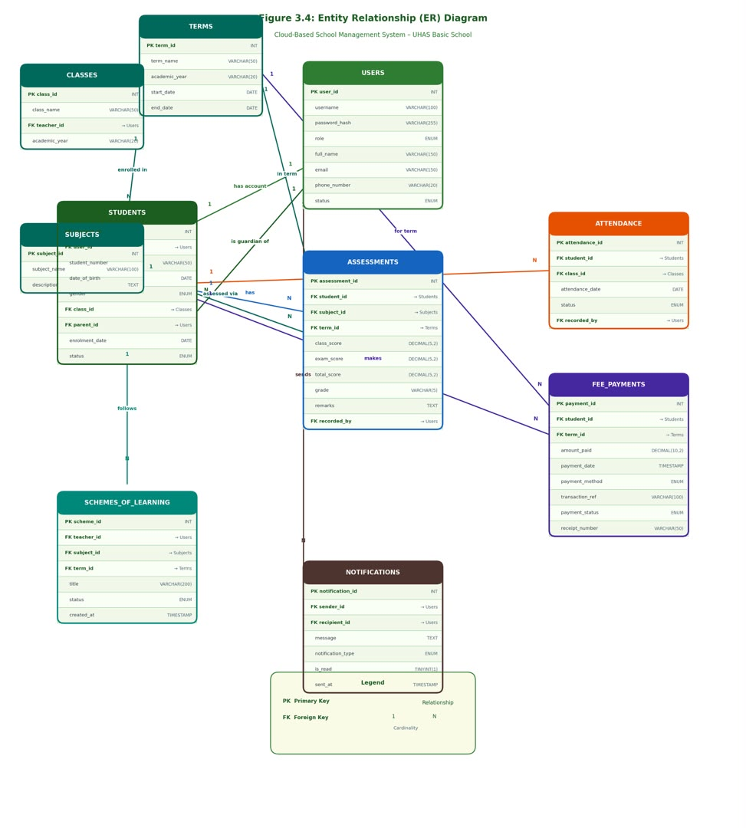
Figure 3.4: Entity Relationship Diagram of the Cloud-Based School Management System

REFERENCES
Almaiah, M. A., Al-Khasawneh, A., & Althunibat, A. (2020). Exploring the critical challenges and factors influencing the e-learning system usage during COVID-19. Education and Information Technologies, 25(6), 5261–5280.
Amazon Web Services. (2023). Amazon Web Services cloud computing services. https://aws.amazon.com
Boateng, R., Mbrokoh, A. S., Boateng, S. L., Senyo, P. K., & Ansong, E. (2021). Determinants of e-learning adoption among students in Ghana. Information Development, 37(1), 97–112.
Laudon, K. C., & Laudon, J. P. (2022). Management information systems: Managing the digital firm (17th ed.). Pearson Education Limited.
Meta. (2023). React – A JavaScript library for building user interfaces. https://react.dev
Oracle Corporation. (2023). MySQL 8.0 reference manual. https://dev.mysql.com/doc/refman/8.0/en
Oyelere, S. S., Suhonen, J., & Sutinen, E. (2020). M-learning: A review of technologies and pedagogical models for modern education. Education and Information Technologies, 25(5), 3813–3837.
Patel, S., & Jain, R. (2019). Automated student information management system. International Journal of Advanced Research in Computer Science, 10(4), 45–52.
Paystack. (2023). Paystack payment gateway documentation. https://paystack.com/docs
Pressman, R. S., & Maxim, B. R. (2020). Software engineering: A practitioner's approach (9th ed.). McGraw-Hill Education.
Sharma, R., & Gupta, P. (2021). Web based school management system for educational institutions. International Journal of Computer Applications, 174(12), 25–31.
Sommerville, I. (2016). Software engineering (10th ed.). Pearson Education Limited.
Tondeur, J., Scherer, R., Siddiq, F., & Baran, E. (2020). Enhancing pre-service teachers' TPACK: A mixed-method study. Computers & Education, 145, 103727.

